**Project Details**

|  |  |
| --- | --- |
| Project number | *9* |
| Project title | *Mega store corporation* |
| Corresponding TA\LA | *LA\Alia Magdy* |
| Deliverable | *1* |

**Team Details**

|  |  |  |
| --- | --- | --- |
| **Student ID** | **Student name** | **Lab Group** |
| 20201203 | Nourhan Amr Abd El-Wahab | S6 |
| 20201189 | Nada Emad Mohammed | S8 |
| 20201041 | Aya Hasanin sayed | S6 |
| 20201191 | Nada Mohammed Ahmed | S1 |
| 20200606 | Nour Yasser Mahmoud | S6 |
| 20201182 | Mai Tarek Ahmed | S8 |
| 20200522 | Mariam Tarek Galal | S5 |

1. Use cases model:
   1. **Using Event Decomposition technique:**

*Table 1- Types of Events*

*Types of Events*

|  |  |
| --- | --- |
| Event | Type  (External/State/temporal) |
| Supplier provides  Products | External |
| Customer enters Location | External |
| Customer Chooses category | External |
| customer uses offers | External |
| customer gains point | state |
| customer chooses a specific Payment Method | External |
| customer returns products within a given time | Temporal |
| Admin provides different Services | External |
| Admin announces offers per limited time | Temporal |
| Marketing Subsystem Provides bags that are good for the environment | External |
| organizer enhances services | External |
| Admin gets alerted of the sold-out item | Temporal |

* + 1. Formalize events with use cases

*Table 2- Formalizing Events to use cases*

|  |  |  |
| --- | --- | --- |
| Event | Type  (External/State/temporal) | Use Case |
| Supplier provides  Products | External | Provide Products |
| Customer enters Location | External | enter Location |
| Customer Chooses category | External | Choose category |
| customer uses offers | External | Use offers |
| customer gains point | state | gain point |
| customer chooses a specific payment Method | External | choose a specific payment Method |
| customer returns products within a given time | Temporal | return products within a given time |
| Admin provides different Services | External | provide different Services |
| Admin announces offers per limited time | Temporal | announce offers per limited time |
| Marketing Subsystem Provides bags that are good for the environment | External | Provide special bags |
| organizer enhances services | External | enhance services |
| Admin gets alerted of the sold-out item | Temporal | Manage warehouses |

* + 1. Use case Descriptions:

*Table 3 - Use cases descriptions*

|  |  |  |
| --- | --- | --- |
| Use case name | Actor | Description |
| Return products | customer | A customer can return products on the same day as food or dairy products if & only if they have gone bad also, he can return products such as appliances if they have physical or technical defects within 14 days (about 2 weeks) only. |
| Check returning products | organizer | Corporation provides many return policies for different products but does not support appliance after-sale services. Organizer checks if the product is Within the period of validity & it has the conditions of return (gone bad or has technical or physical defects) |
| Choose a specific payment method | customer | Customer can choose any payment method such as visa, cash, or points, there are offers available for the customer affected by this payment method, these different payment techniques and packages help customer gains points per purchase operation |
| Provide products | supplier | Corporation Contracts with different suppliers to provide the best products & to cover the many warehouses it has; the suppliers have an annual contract for that. |
| Manage warehouses | admin | If there is a deficiency, the admin should contact the supplier and make sure that warehouses are full, & the products are valid. |
| Gain points | customer | Customers can gain points through purchase operations & using reusable bags, these points are affected by special offers announced for a limited time. |
| Provide special bags | Marketing subsystem | The marketing section provides special bags that help in reducing plastic waste and helps the recycling operation. These bags are reusable and help customers gain points |
| Search for the exact product | customer | Customer Looking for or purchasing a product in abundance that will be saved in their history on the system will help it enhance its services |
| Enhance services | Organizer | Organizers enhance services on the website, mobile application, or on-site based on the most searched and requested product by the customers |
| Support many categories | organizer | Organizers provide a lot of categories for customers like fruits and vegetables, dairy products, meat and poultry, grocery, beverages, cooking ingredients |
| Provide different services | admin | Admin provides various services to the customer; the customer will be easy for him to buy and shop. |
| Provide onsite | admin | Admin provides onsite service, Customer visit the physical location. |
| Provide offsite | admin | Admin provides online service; Customer will use online services. |
| Provide website | admin | Admin provides online service  By website, customers use the website and enter the country. |
| Provide application | admin | Admin provides online service  By application, the customer uses the application and enters the location. |
| Enter country | customer | The customer will enter the country when he uses the website, The system will allow him to shop and buy |
| Enter location | customer | The customer will enter a location when he uses the application, The system will allow him to shop and buy |
| Choose categories | customer | Customers choose categories if the customer uses online services the system will be shown all categories for him. |
| Use offers | customer | Customers will use special offers announced for a limited time or different offers throughout the year that vary with the occasion, either affected by local  or global events, if customers use special offers announced for a limited time The system will earn the customer some points |
| Announce offers | admin | admin offers different offers throughout the year that vary with the occasion, either affected by local  or global events. For example, in the new year, there are special offers for pastry products, TVs, and kitchen appliances These offers can also differ per country and payment method, and offer special offers announced for a limited time, it will attract  more customer, the customer will take advantage of these offers |
| Gain competition | admin | Admin will gain competition with admins in different stores by providing various payment techniques and packages |

**Assumptions**

1. We have three payment techniques like cash, visa, and points that will help it gain points per purchase.
2. Every time a customer search for an exact product this will be saved on the system as the customer's history by increasing searching about the same product system will enhance services to make the customer up to date with this product’s offers. If there is a big demand for an exact product or existing of two products or more in customers' purchases the store will enhance services to make these products available together or make offers for that
   * 1. Matrix that maps all domain classes to the set of use cases

|  |  |  |  |  |  |
| --- | --- | --- | --- | --- | --- |
| Use case  **Vs.**  Domain Class | Domain Class 1 | Domain Class 2 | Domain  Class 3 | Domain Class 4 | Domain Class 5 |
| **provide products** | Product | Supplier | City | country | SupplierOfProduct |
| **enters country** | Customer | Special Offers | Country | Website | Store |
| **enters Location** | Customer | Application |  |  |  |
| **choose Category** | Customer | Category |  |  |  |
| **uses offers** | Customer | Special Offers | Points | UsedOffersOfCustomer | CustomePoints |
| **gain points** | Customer | Points | Special Bags | payment Technique | SpecialOffers |
| **choose specific Payment** | Payment Technique | Customer | CustomerPoints |  |  |
| **pays by visa** | PayingByVisa | Customer | points | CustomerPoints |  |
| **Pays cash** | PayingByCache | Customer | points | CustomerPoints |  |
| **pays by points** | PayingByPoints | Customer | points | CustomerPoints |  |
| **return Products** | ReturnOf  Products | ReturnOfBadProducts | ReturnOfIncludedProductsOfPhysicaOrTechnicalDefect | Customer | ProductReturnOfCustomer |
| **return product has gone bad** | BadProduct | Customer | ProductReturnOfCustomer |  |  |
| **return products include physical or technical defect** | ReturnOfIncludedProductsOfPhysicaOrTechnicalDefect | Customer | ProductReturnOfCustomer |  |  |
| **support many categories** | Organizer | Category |  |  |  |
| **check returning products** | Organizer | ReturnOf  Products |  |  |  |
| **enhance services** | Organizer | ServicesEnhance | SearchHistory |  |  |
| **manage warehouses** | Admin | Warehouses | OwnedWarehouses | RentedWarehouses | Country |
| **provide different services** | DifferentServices | OnsiteServices | OffsiteServices | Admin |  |
| **provide on_site** | OnsiteServices | Admin |  |  |  |
| **provide off_site** | OffsiteServices | Admin | Website | Application |  |
| **provide website** | Website | Country | Admin |  |  |
| **provide application** | Application | Admin | Customer |  |  |
| **announce offers** | Admin | Special offers | Country |  |  |
| **gain competition** | Admin | PaymentTechnique |  |  |  |
| **provide special bags** | Marketingsubsystem | SpecialBags | Points |  |  |
| **search for exact product** | Customer | Product | ProductSearch |  |  |

|  |  |
| --- | --- |
| enters country | CountryOffers |
| gain points | CustomerPoints |

* + 1. Use case Diagram:

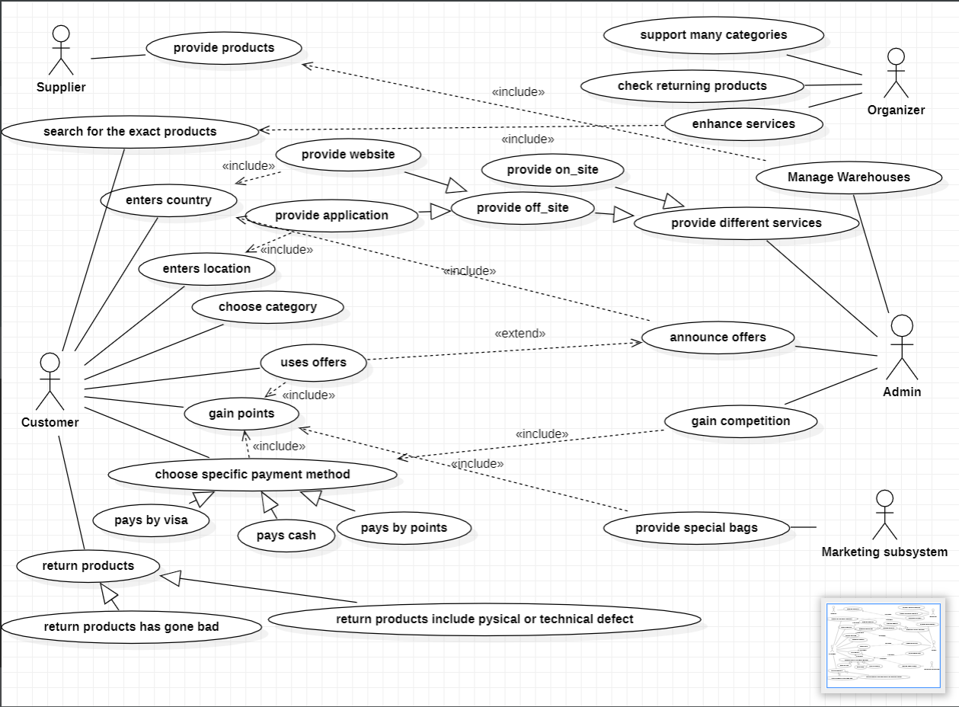

**Note that:**

We used StarUML.